­­­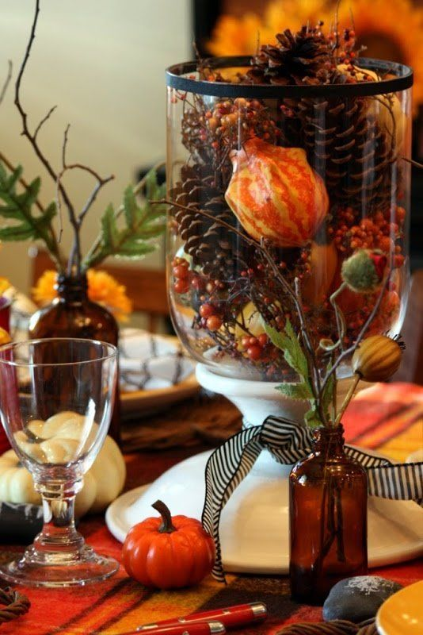

Save The Date!

Saturday, September 3rd, 2022

10:00-5:00

Join us, to celebrate the

change of the season

Fall Fling

[](https://transitionaldesign.net/)

601 Towpath Rd, Broadview Heights, OH 44147

(440)-627-6390

Refreshments & Raffle